Serverless Student Attendance Management System
Prepared in the partial fulfillment of the Summer Internship Program on AWS
AT


Under the guidance of
Mrs. Sumana Bethala, APSSDC
&
Mr Juttuka Lovababu
Submitted by
L.Satwika, 23A51A0534,Aditya Institute of Technology and Management
ladesatwika@gmail.com (Batch1)
D.Akash ,238W1A5415, Velagapudi Ramkrishna Siddhartha Engineering College, akashdamerla@gmail.com ,(Batch1)
D. Venkat Charan Teja,AP25110010590, SRM-AP University
charandamerla1@gmail.com (Batch1)
V.Ramya Sree,23KD1A05P4,Lendi Institute of Engineering and Technology
ramyasree36714@gmail.com (Batch1)
J.S.Jahnavi,234M1A0549,VEMU Institute of Engineering and Technology,
joythijahanavi@gamil.com (Batch1)
ACKNOWLEDGEMENT
I would like to express my heartfelt gratitude to all those who have contributed to the successful completion of my summer internship project at Andhra Pradesh Skill Development Corporation (APSSDC). This opportunity has been an enriching and transformative experience for me, and I am truly thankful for the support, guidance, and encouragement I have received along the way.
First and foremost, I extend my sincere regards to Mrs. Sumana Bethala& Mr Juttuka Lovababu,my supervisors and mentors, for providing me with valuable insights, constant guidance, and unwavering support throughout the duration of the internship. Their expertise and encouragement have been instrumental in shaping the direction of this project.
I would like to thank the entire team at Andhra Pradesh Skill Development Corporation (APSSDC) for fostering a collaborative and innovative environment. The camaraderie, knowledge sharing, and feedback I received from my colleagues significantly contributed to the development and success of this project.
In conclusion, I am honoured to have been a part of this internship program, and I look forward to leveraging the skills and knowledge gained to contribute positively to future endeavours.
Thank you.
Sincerely,
L.Satwika, 23A51A0534,Aditya Institute of Technology and Management
ladesatwika@gmail.com (Batch1)
D.Akash ,238W1A5415, Velagapudi Ramkrishna Siddhartha Engineering College, akashdamerla@gmail.com ,(Batch1)
D. Venkat Charan Teja,AP25110010590, SRM-AP University
charandamerla1@gmail.com (Batch1)
V.Ramya Sree,23KD1A05P4,Lendi Institute of Engineering and Technology
ramyasree36714@gmail.com (Batch1)
J.S.Jahnavi,234M1A0549,VEMU Institute of Engineering and Technology,
joythijahanavi@gamil.com (Batch1)

ABSTRACT
The Serverless Student Attendance Management System is a cloud-based application developed using Amazon Web Services (AWS) to automate attendance management in educational institutions. Traditional attendance systems require significant manual effort and infrastructure maintenance, whereas this project leverages serverless computing to eliminate server management while ensuring scalability, availability, and cost efficiency.
The application uses Amazon API Gateway to expose REST APIs, AWS Lambda for backend processing, Amazon DynamoDB for storing attendance records, Amazon Cognito for user authentication, and Amazon S3 for hosting the web application.
The proposed solution provides secure authentication, role-based access, automated attendance recording, real-time attendance reports, and rapid deployment. The serverless architecture significantly reduces operational complexity while improving application reliability and scalability.
Keywords: AWS, Serverless, Lambda, API Gateway, DynamoDB, Cognito, DevOps, Attendance management.

TABLE OF CONTENTS

S.No Content
1. INTRODUCTION
2.METHODLOGY
3.TECNOLOGY STACK
4.SYSTEM DESIGN/ARCHITECTURE
5.IMPLEMENTION
6.RESULTS
7.CONCLUSION

CHAPTER 1: INTRODUCTION
1.1 Introduction
Educational institutions rely on attendance management systems to monitor student participation, maintain academic records, and comply with institutional policies. Traditional attendance methods, such as paper registers or standalone desktop applications, are often time-consuming, prone to human error, and difficult to maintain. These approaches also make it challenging to access attendance records in real time and generate accurate reports.
Advances in cloud computing have enabled the development of scalable, reliable, and cost-effective applications. Serverless computing, in particular, allows developers to build and deploy applications without managing servers, reducing infrastructure complexity while automatically scaling resources based on demand. This approach enables institutions to focus on application functionality instead of server administration.
The Serverless Student Attendance Management System is a cloud-native application developed to automate attendance management using Amazon Web Services (AWS). The system enables faculty members to record student attendance electronically, while students can securely access their attendance records and monitor their attendance percentage through a web-based interface.
The application is built using AWS serverless services, including Amazon API Gateway for exposing REST APIs, AWS Lambda for executing backend logic, Amazon DynamoDB for storing attendance records, Amazon Cognito for secure user authentication, and Amazon S3 for hosting the frontend application. Amazon CloudWatch is used to monitor application performance and logs, ensuring operational visibility.
The proposed system offers several advantages over traditional attendance management solutions, including automatic scalability, high availability, enhanced security, lower operational costs, and simplified maintenance. By combining serverless architecture with DevOps practices, the project demonstrates how modern cloud technologies can be applied to solve real-world problems in educational institutions.
Overall, the Serverless Student Attendance Management System provides a secure, scalable, and efficient solution for managing student attendance while showcasing the practical implementation of cloud computing, serverless architecture.

.
CHAPTER 2: METHODOLOGY
2.1 Methodology
The Serverless Student Attendance Management System was developed using a cloud-native approach that combines serverless computing with DevOps practices. The system is designed to automate attendance management while ensuring scalability, security, and high availability.
The development process began with requirement analysis, where the functional and non-functional requirements were identified. Based on these requirements, a serverless architecture was designed using AWS services.
The frontend application is hosted on Amazon S3, while Amazon Cognito is used for secure user authentication. All client requests are sent through Amazon API Gateway, which invokes AWS Lambda functions to process attendance-related operations. Attendance records are stored in Amazon DynamoDB, providing fast and scalable data storage. Amazon CloudWatch is used to monitor application logs and performance.
Methodology Workflow
Requirement Analysis
↓
System Design
↓
Frontend Development (Amazon S3)
↓
Backend Development (AWS Lambda)
↓
API Integration (Amazon API Gateway)
↓
Database Integration (Amazon DynamoDB)
↓
Authentication (Amazon Cognito)
↓
Testing
↓
Deployment and Monitoring (Amazon CloudWatch)

Summary
The adopted methodology enabled the development of a secure, scalable, and cost-effective attendance management system. By leveraging AWS serverless services and an automated CI/CD pipeline, the project achieved reliable performance, simplified maintenance, and efficient application deployment.

CHAPTER 3: TECHNOLOGIES USED
The following technologies and tools were used to develop the Serverless Student Attendance Management System with CI/CD on AWS.
Category | Technology/Service | Version | Purpose
Frontend | HTML5 | Latest | Used to create the structure of the web pages.
Frontend | CSS3 | Latest | Used for styling and responsive user interface design.
Frontend | JavaScript (ES6) | ES6+ | Used for client-side functionality, form validation, and user interactions.
Backend | Python | 3.14* | Used to develop AWS Lambda functions and backend business logic.
Compute Service | AWS Lambda | Latest | Executes backend code without managing servers.
API Service | Amazon API Gateway (REST API) | Latest | Provides REST APIs for communication between the frontend and backend.
Database | Amazon DynamoDB | Latest | Stores student, faculty, and attendance records.
Storage | Amazon S3 | Latest | Hosts the static frontend website and stores application assets.
Cloud Platform | Amazon Web Services (AWS) | Latest | Provides the cloud infrastructure and managed services for the application.
Identity & Access Management | Amazon IAM | Latest | Manages user roles and permissions for secure access to AWS resources.
Monitoring | Amazon CloudWatch | Latest | Monitors application performance and stores logs for troubleshooting.
Version Control | Git | Latest | Tracks source code changes and manages version history.
Source Code Repository | GitHub | Latest | Stores and manages the project source code.
API Testing | Postman | Latest | Tests and validates REST API endpoints.
Development Environment | Visual Studio Code | Latest | Used for frontend and backend development.
Browser | Google Chrome | Latest | Used for testing, debugging, and validating the web application.
Architecture | Serverless Architecture | — | Enables scalable, highly available, and cost-effective application deployment using AWS managed services.
Frontend Technology Stack
- HTML5 – Used to build the structure of the web pages.
- CSS3 – Used for styling and creating a responsive user interface.
- JavaScript (ES6) – Used for client-side functionality, form validation, and dynamic user interactions.
- Visual Studio Code – Used as the primary code editor for frontend development.
- Google Chrome – Used for testing, debugging, and verifying application functionality.
- Git – Used for version control and tracking changes in the source code.
- GitHub – Used to host and manage the frontend source code repository.
Backend Technology Stack
- Python – Used to implement the backend business logic.
- AWS Lambda – Executes serverless backend functions in response to API requests.
- Amazon API Gateway – Creates secure REST APIs for communication between the frontend and backend.
- Amazon DynamoDB – Stores attendance records and user information in a scalable NoSQL database.
- Amazon IAM – Controls secure access to AWS resources through roles and permissions.
- Amazon CloudWatch – Monitors application logs, metrics, and overall system performance.
DevOps and Deployment Tools
- Amazon S3 – Hosts the static frontend website.
- Git – Maintains source code history and supports collaborative development.
- GitHub – Serves as the central repository for source code management and deployment workflows.

CHAPTER 4.SYSTEM DESIGN / ARCHITECTURE
The Serverless Student Attendance Management System with CI/CD on AWS is designed using a modular and serverless architecture to provide a secure, scalable, and efficient attendance management solution. The system separates the frontend, backend, authentication, database, and deployment processes into independent components, making the application easy to maintain and extend.
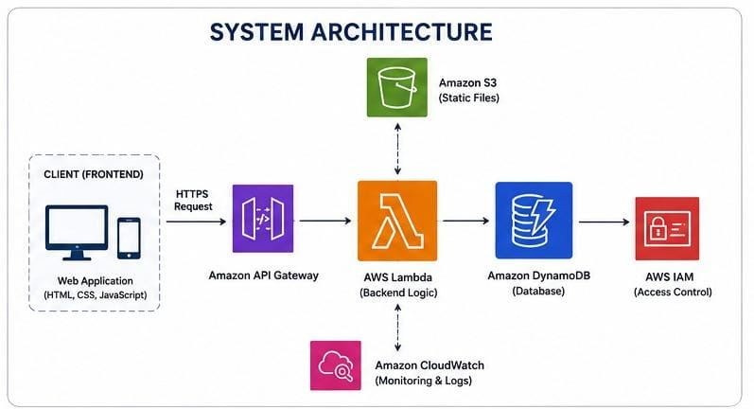
IAM:-

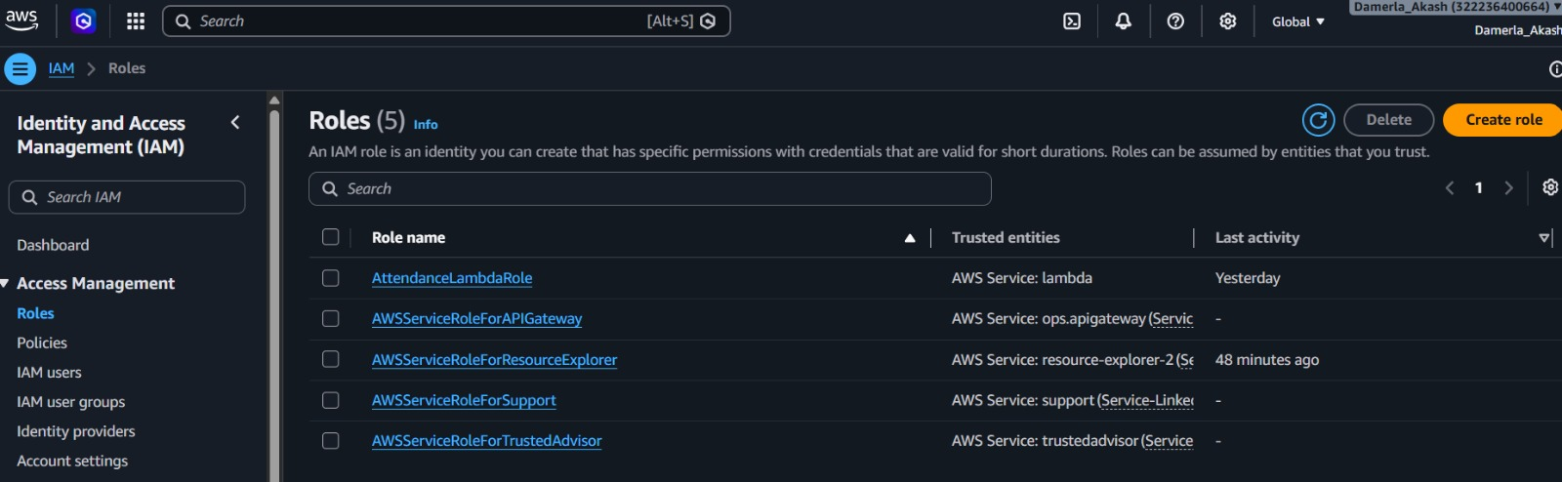
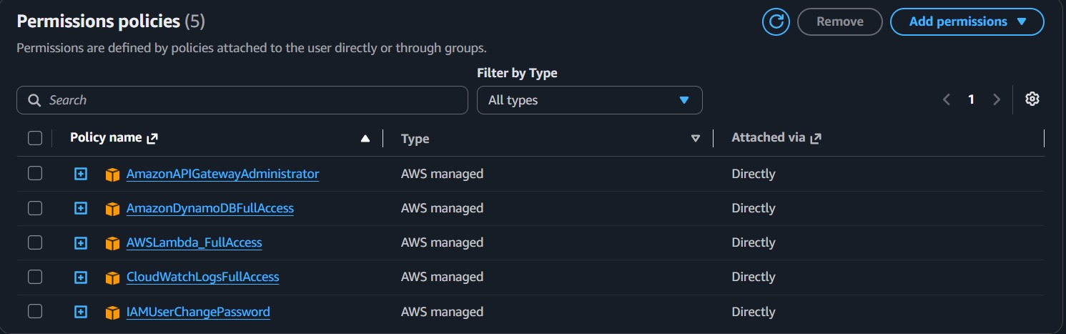
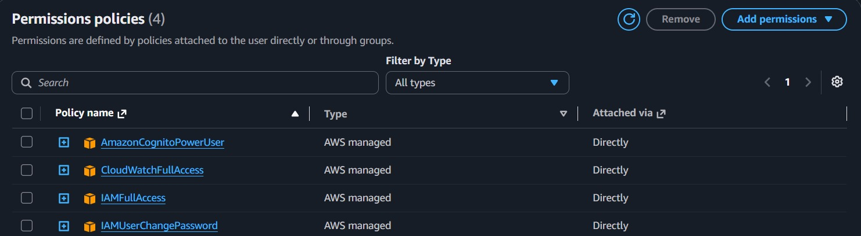

LAMBDA:-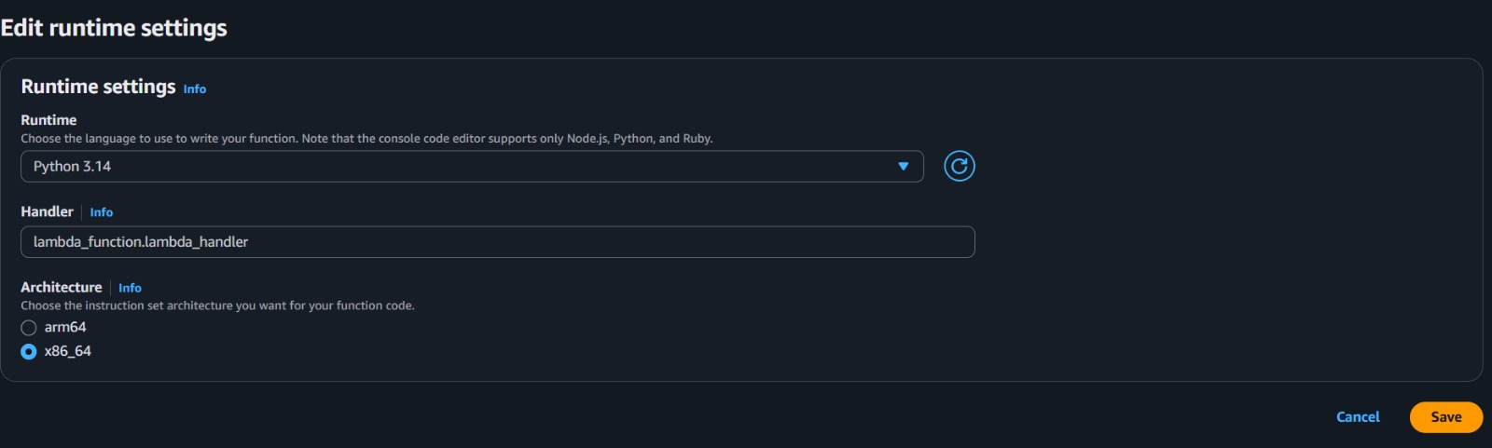

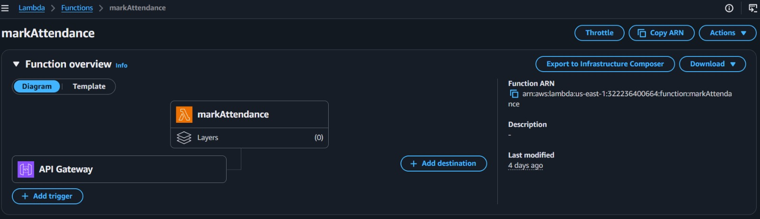
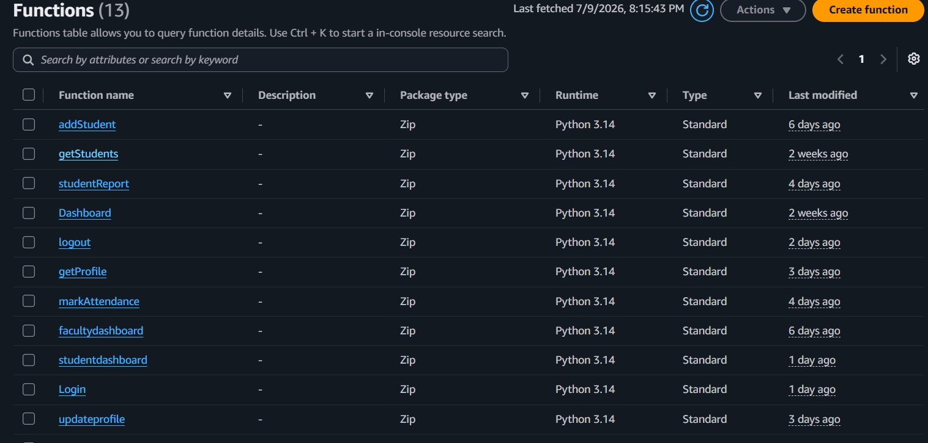
CLOUD WATCH:-
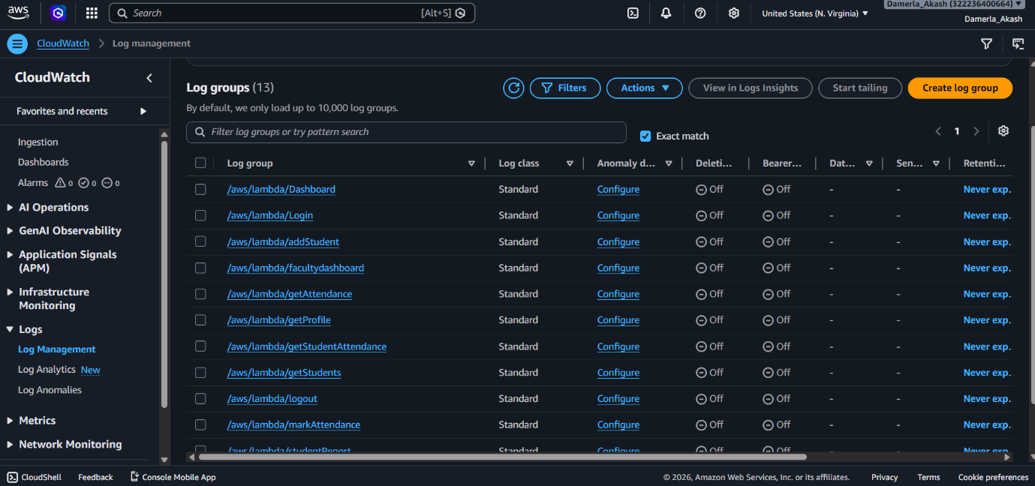
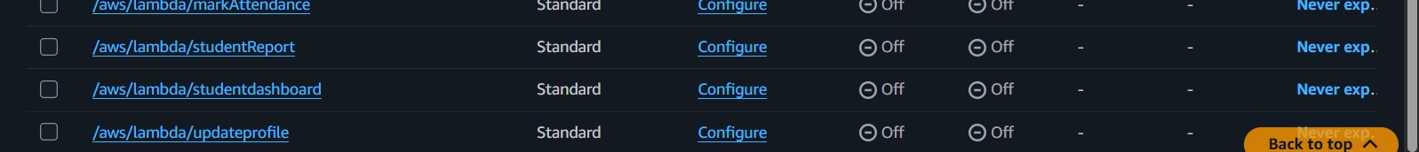
DYNAMO DATA BASE:-
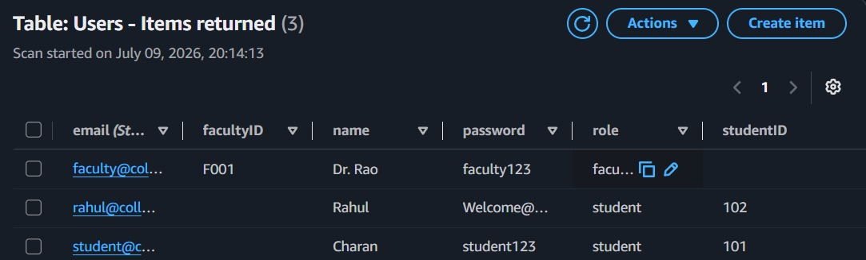
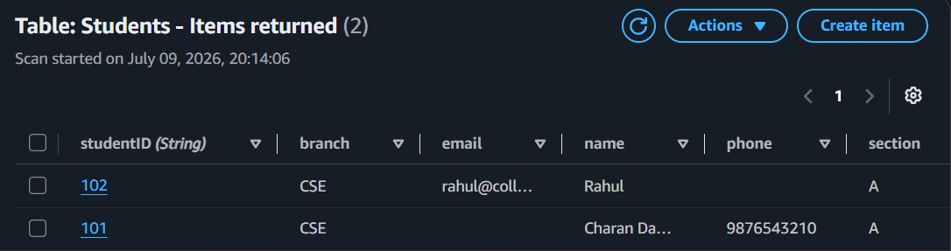
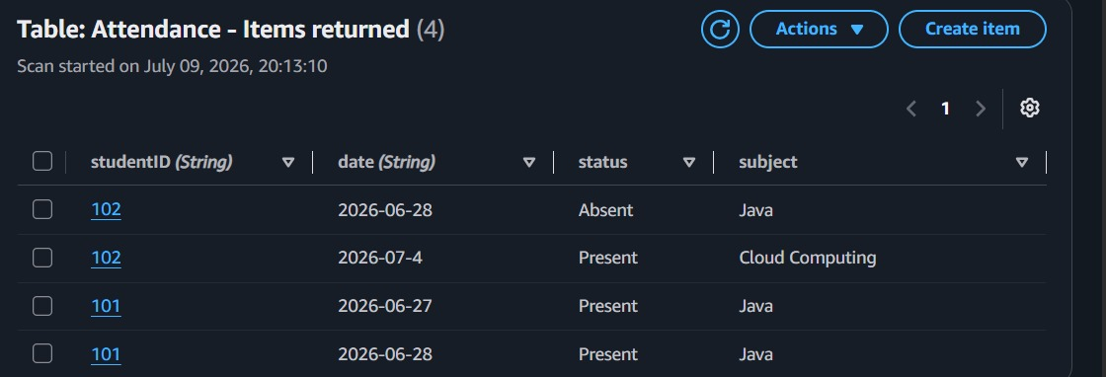
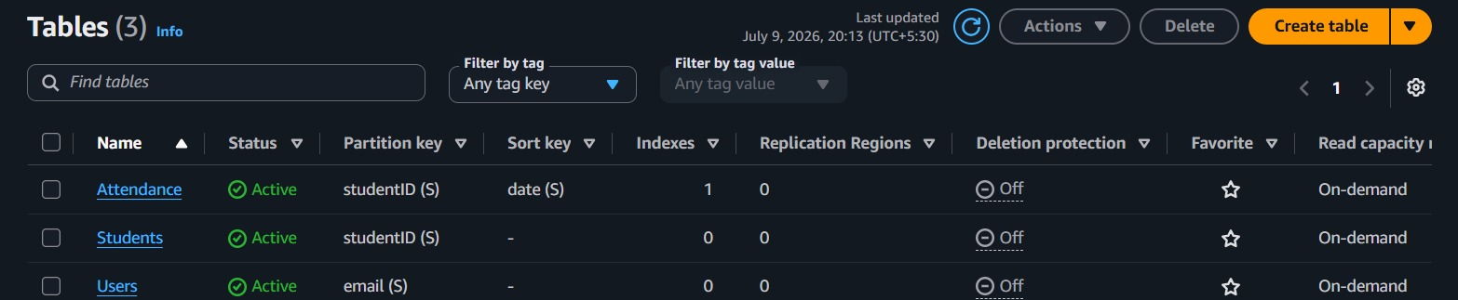
API GATEWAY:-
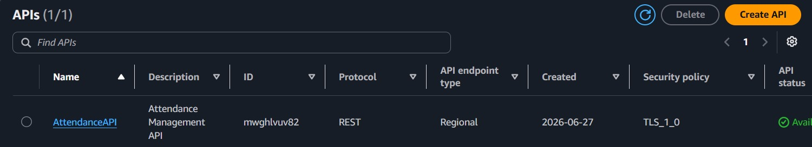
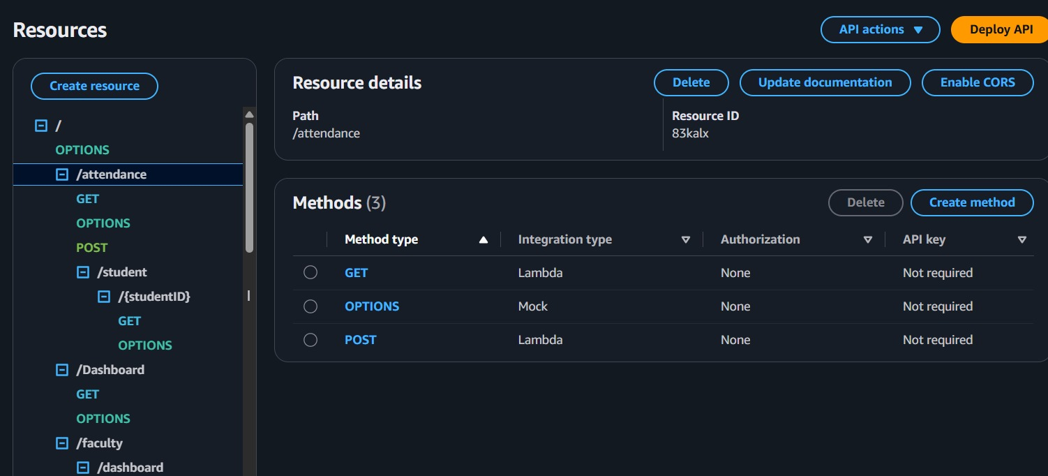
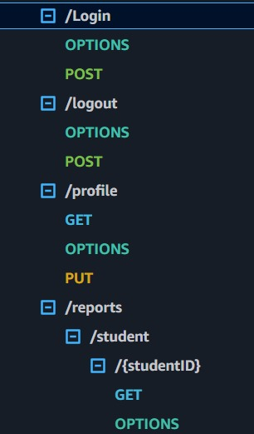
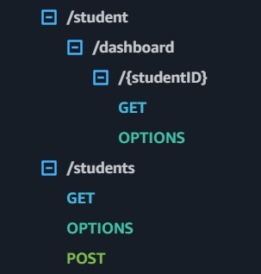
AMAZON S3:-
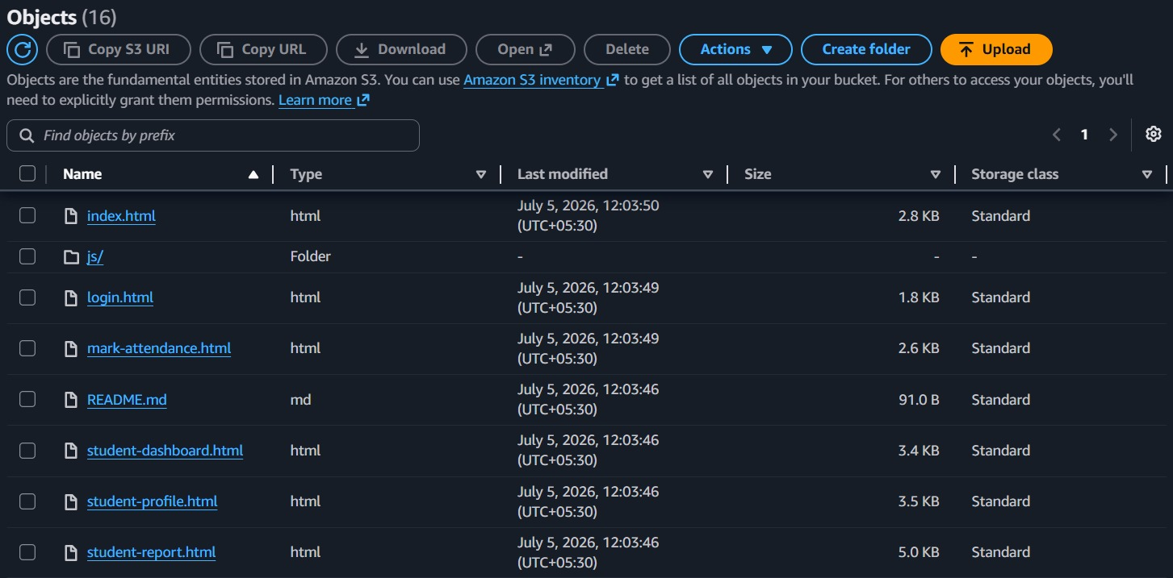
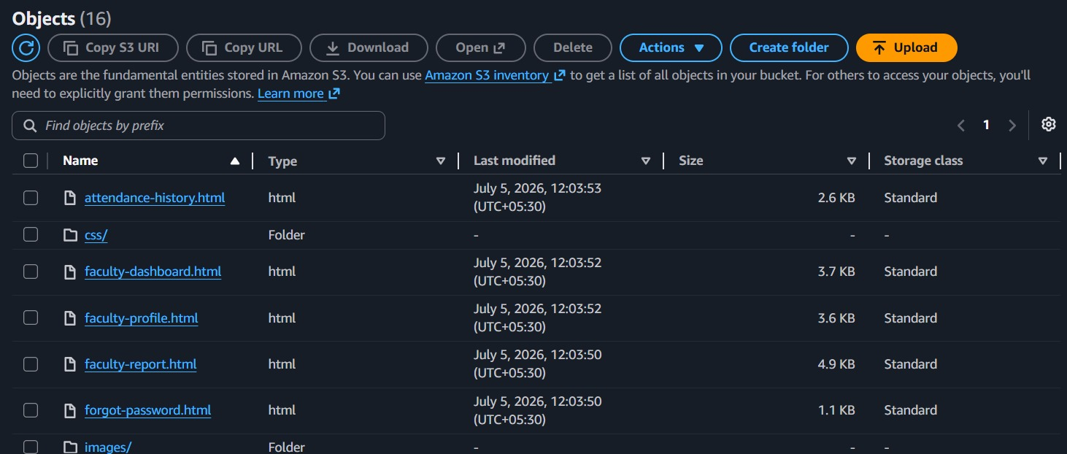
CHAPTER 5: IMPLEMENTATION PROCESS
5.1 Implementation Process
The Serverless Student Attendance Management System was implemented using a serverless architecture to provide a scalable, secure, and cost-effective solution for managing student attendance. The implementation involved developing the frontend, backend, database, authentication, and deployment pipeline using AWS services.
Step 1: Frontend Development
The user interface was developed using HTML5, CSS3, and JavaScript (ES6). The frontend provides separate login pages and dashboards for students, faculty, and administrators. After development, the static website files were deployed to Amazon S3, which hosts the application and makes it accessible through a web browser.
Step 2: User Authentication
User authentication was implemented using Amazon Cognito. Cognito manages user registration, login, and secure authentication. After a successful login, authenticated users can access the application according to their assigned roles.
Step 3: API Development
REST APIs were created using Amazon API Gateway. These APIs receive requests from the frontend and securely forward them to the backend AWS Lambda functions. API Gateway serves as the communication layer between the client application and the backend services.
Step 4: Backend Development
The backend logic was implemented using AWS Lambda with Python. Lambda functions handle operations such as user authentication, attendance marking, attendance retrieval, and report generation. Since Lambda is serverless, it automatically scales based on incoming requests.
Step 5: Database Integration
Amazon DynamoDB was used as the database to store student information, faculty details, and attendance records. Lambda functions perform Create, Read, Update, and Delete (CRUD) operations on DynamoDB whenever users interact with the application.
Step 6: Monitoring and Logging
Amazon CloudWatch was configured to monitor the application's performance and collect logs generated by Lambda functions. CloudWatch helps identify errors, monitor API requests, and troubleshoot issues during development and deployment..
Step 7: Testing
The completed application was tested using Postman for API validation and Google Chrome for frontend testing. Functional testing was performed to verify user authentication, attendance marking, database operations, and report generation. All modules were successfully integrated and tested before deployment.
5.2 Implementation Workflow
The implementation process followed the sequence below:
Requirement Analysis
↓
Frontend Development (HTML, CSS, JavaScript)
↓
User Authentication (Amazon Cognito)
↓
REST API Development (Amazon API Gateway)
↓
Backend Development (AWS Lambda – Python)
↓
Database Integration (Amazon DynamoDB)
↓
Monitoring (Amazon CloudWatch)
↓
Version Control (Git & GitHub)
↓
Deployment (Amazon S3 & AWS Services)
↓
Testing and Validation
5.3 Summary
The implementation process successfully integrated AWS serverless services to build a secure and scalable attendance management system. The use of Amazon S3, API Gateway, Lambda, DynamoDB, Cognito, and CloudWatch enabled efficient application development, while GitHub Actions automated the deployment process through CI/CD. This implementation reduced infrastructure management, improved deployment efficiency, and ensured reliable application performance.

CHAPTER 6: RESULTS
6.1 Results
The Serverless Student Attendance Management System was successfully designed, developed, and deployed using AWS serverless services. The application met the project objectives by providing a secure, scalable, and automated solution for managing student attendance.
The frontend application was successfully hosted on Amazon S3, allowing users to access the system through a web browser. Amazon Cognito provided secure authentication for students, faculty, and administrators, ensuring that only authorized users could access the application.
The backend services were implemented using AWS Lambda, where business logic such as attendance marking, attendance retrieval, and report generation was executed efficiently. Amazon API Gateway enabled secure communication between the frontend and backend by exposing REST APIs.
Attendance records were stored and managed using Amazon DynamoDB, which provided fast data access and automatic scalability. Amazon CloudWatch was used to monitor application performance and store execution logs, helping identify and resolve issues during development and deployment.
Functional testing confirmed that all major modules operated correctly. Users were able to log in securely, mark attendance, retrieve attendance records, and view attendance information without errors. API endpoints were validated using Postman, and the frontend was tested using Google Chrome to ensure proper functionality and responsiveness.
Overall, the project demonstrated the effectiveness of serverless architecture in building a modern attendance management system. The application achieved high availability, reduced infrastructure management, automated deployment, and improved scalability while maintaining secure access to student attendance records.
6.2 Key Outcomes
- Successfully developed a serverless web application for attendance management.
- Hosted the frontend on Amazon S3.
- Implemented secure user authentication using Amazon Cognito.
- Developed REST APIs using Amazon API Gateway.
- Implemented backend logic using AWS Lambda.
- Stored attendance data securely in Amazon DynamoDB.
- Monitored application performance using Amazon CloudWatch.
- Verified application functionality through API and browser testing.
- Achieved a scalable, secure, and cost-effective cloud-based solution.
6.3 Summary
The project successfully fulfilled its objectives by delivering a reliable and efficient Student Attendance Management System using AWS serverless technologies. The integration simplified deployment, while the serverless architecture improved scalability, reduced operational overhead, and enhanced overall system performance. The developed application serves as a practical example of applying cloud computing and DevOps practices to solve real-world challenges in educational institutions.
6.4 Output Screenshots:-
HOME PAGE:-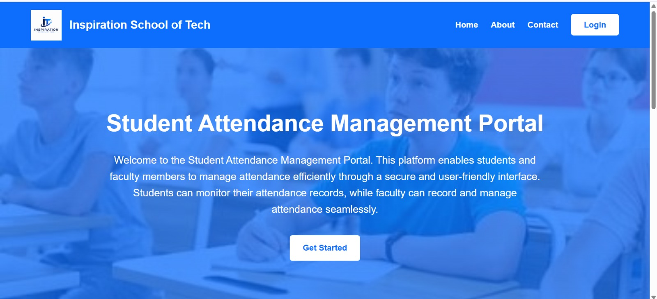
Login page:-
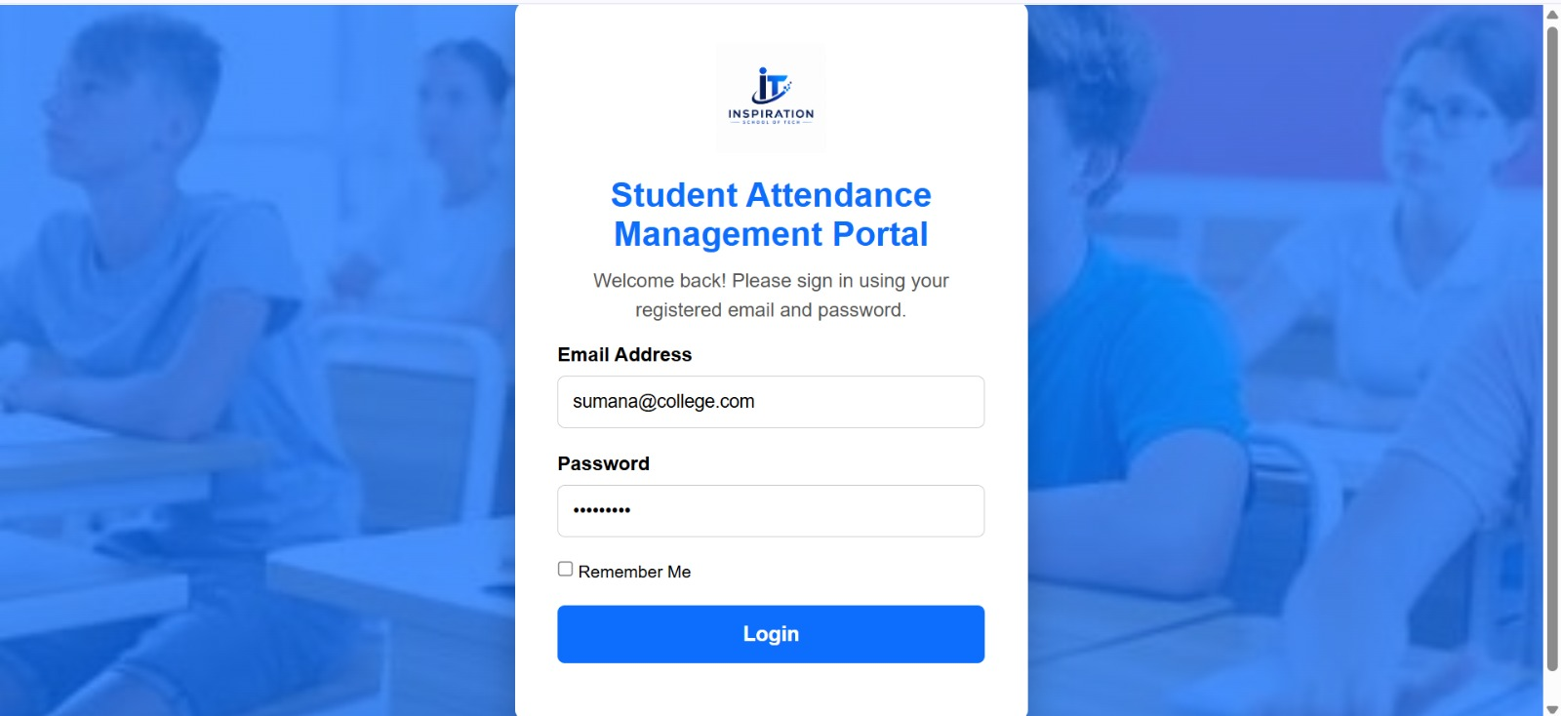

Faculty Dashboard page:-
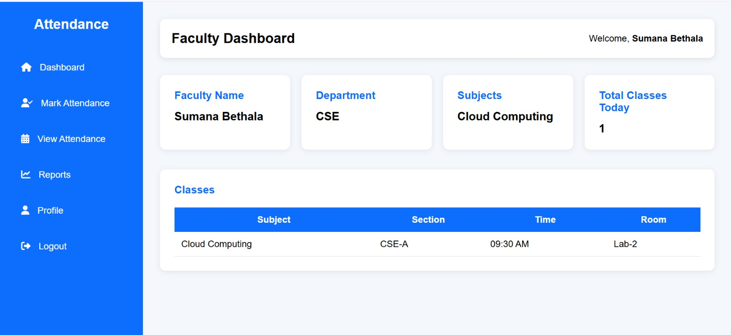
Faculty Dashboard-Mark Attendance Pages:-
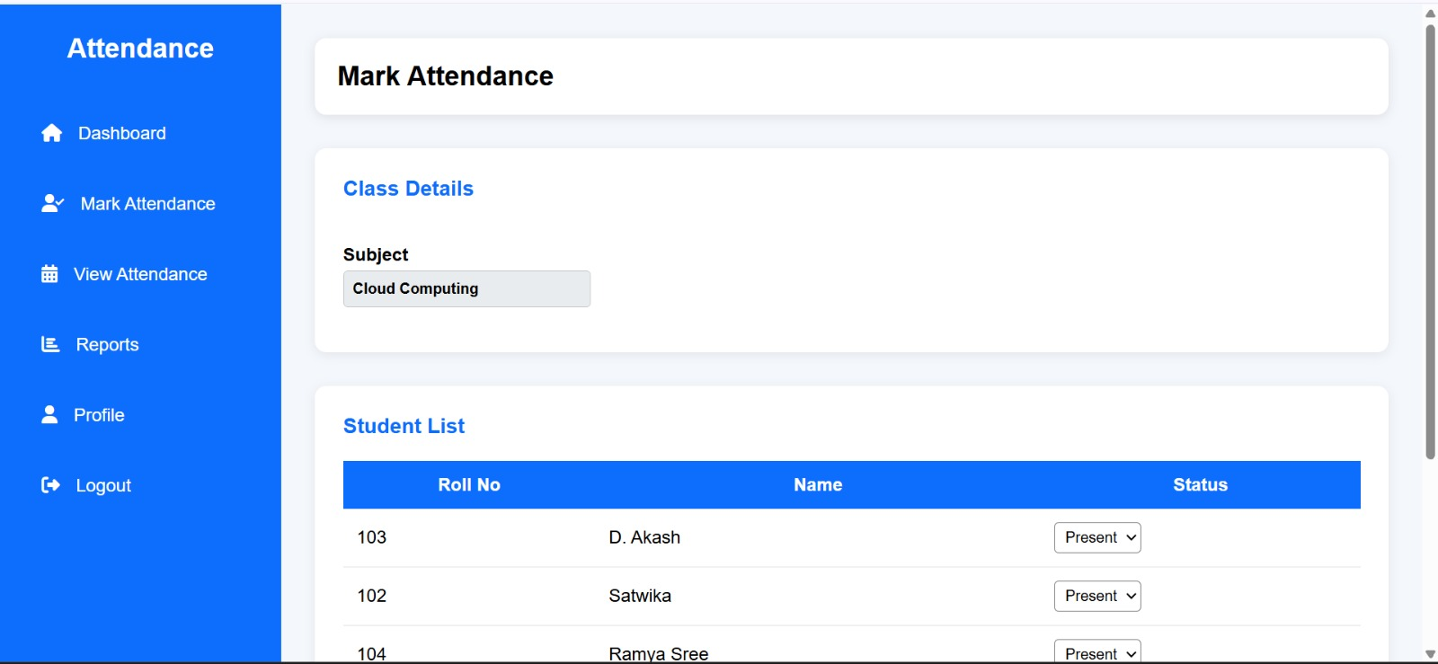
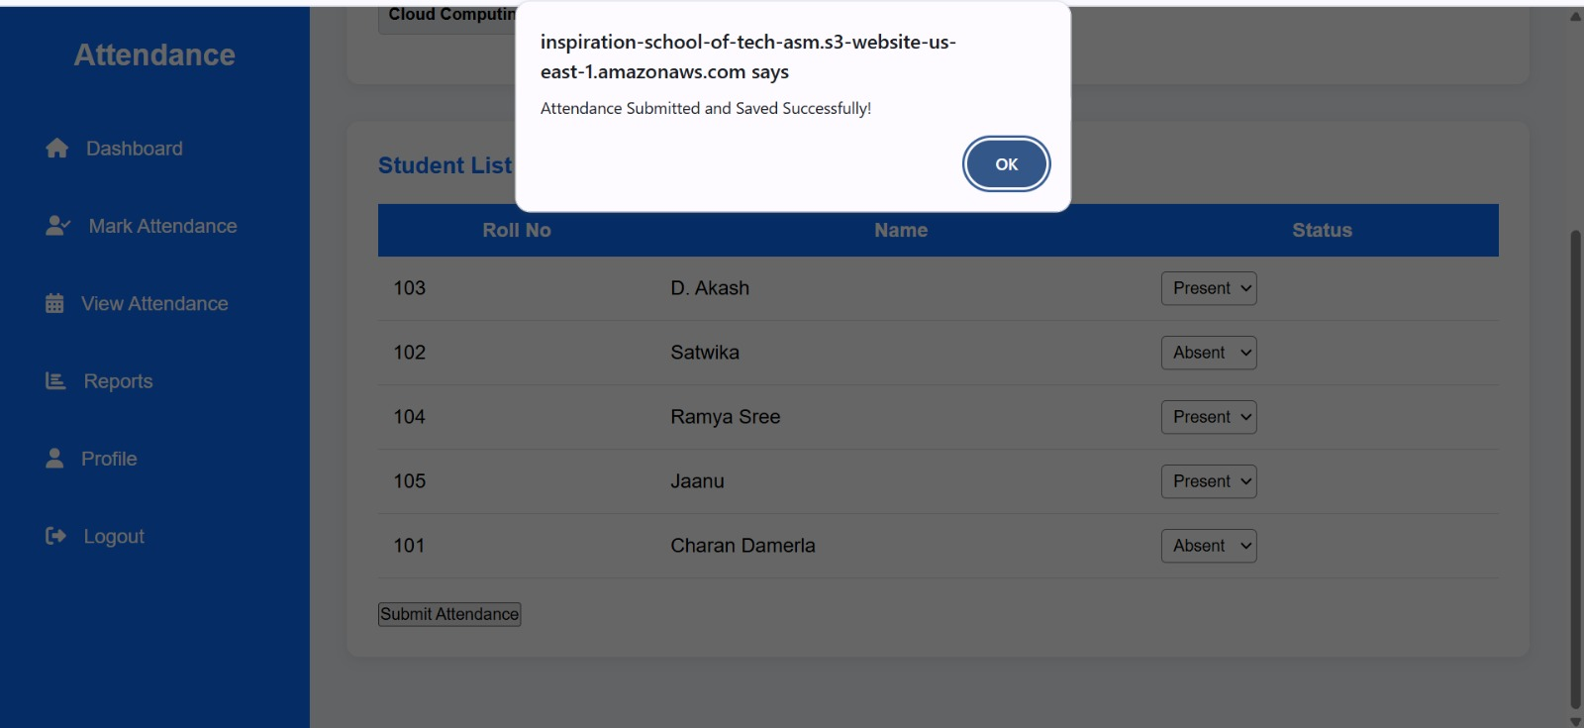
Faculty Dashboard-View Attendance Page:-
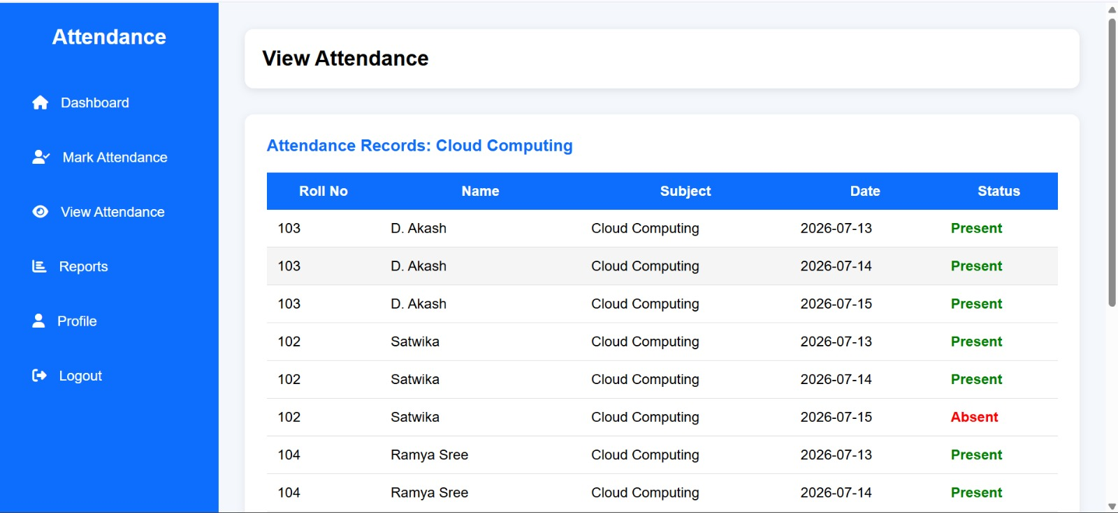
Faculty Dashboard-Reports pages:-
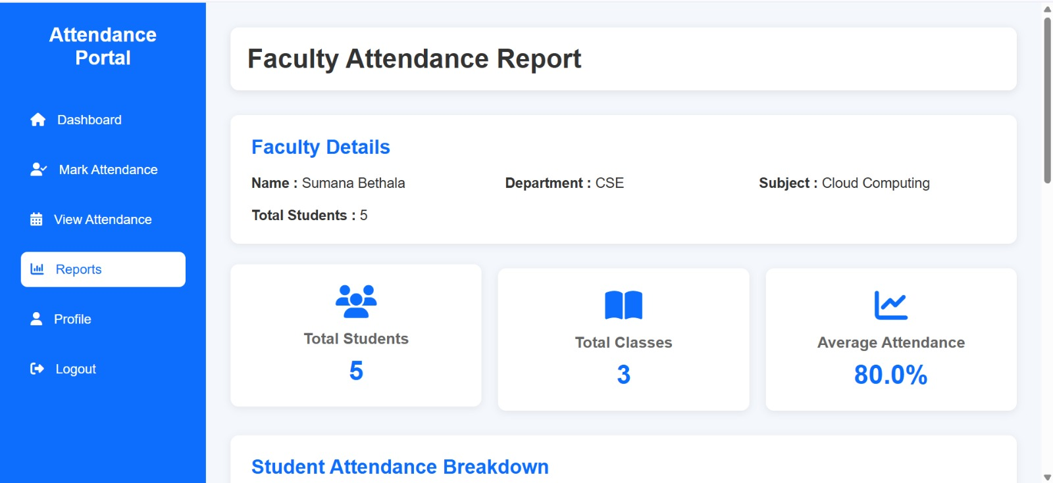
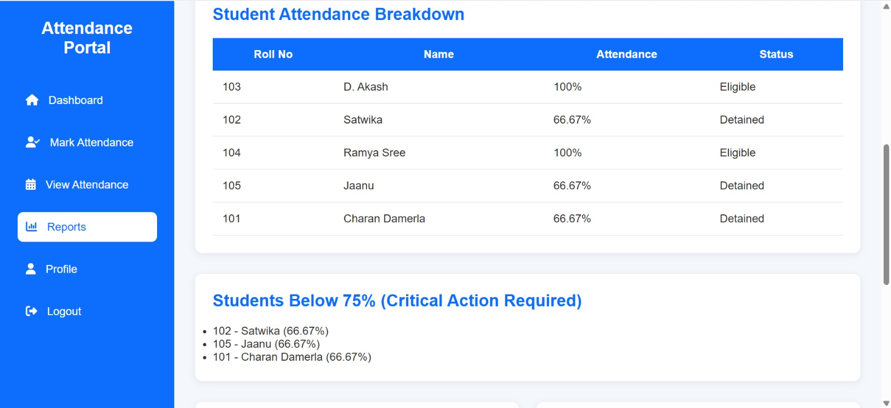
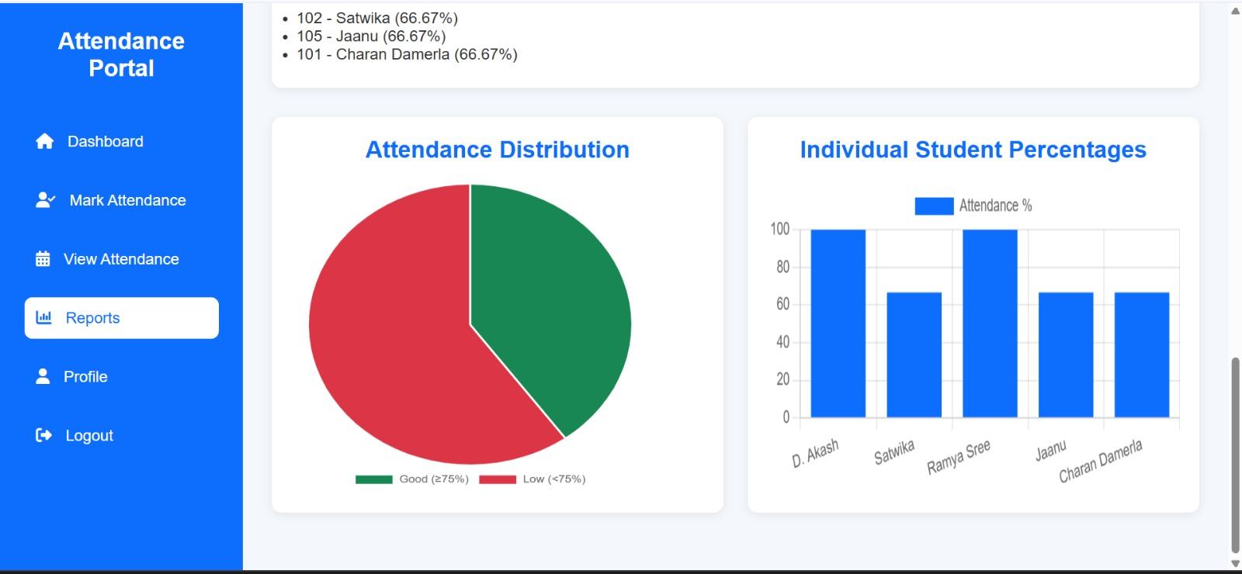
Faculty Dashboard-Profile Page:-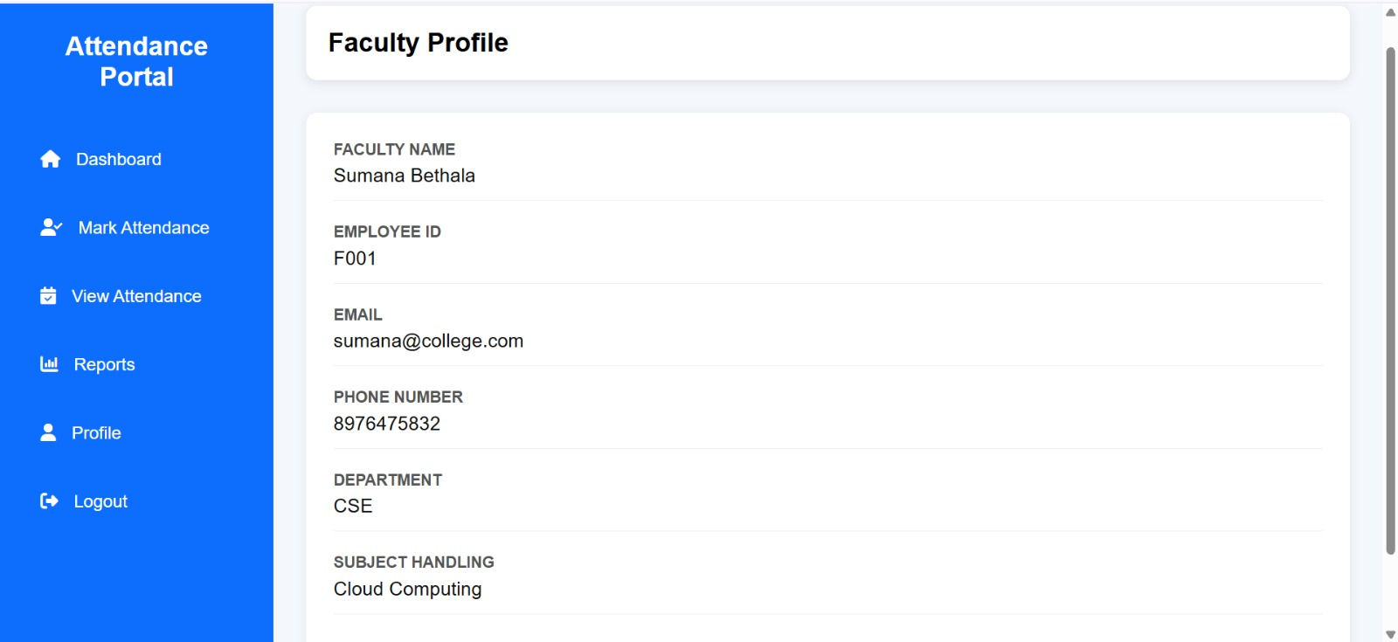
Student Dahboard Page:-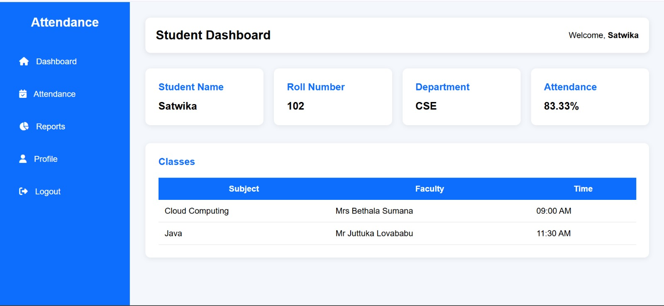
Student Dashboard-Attendance History Page:-
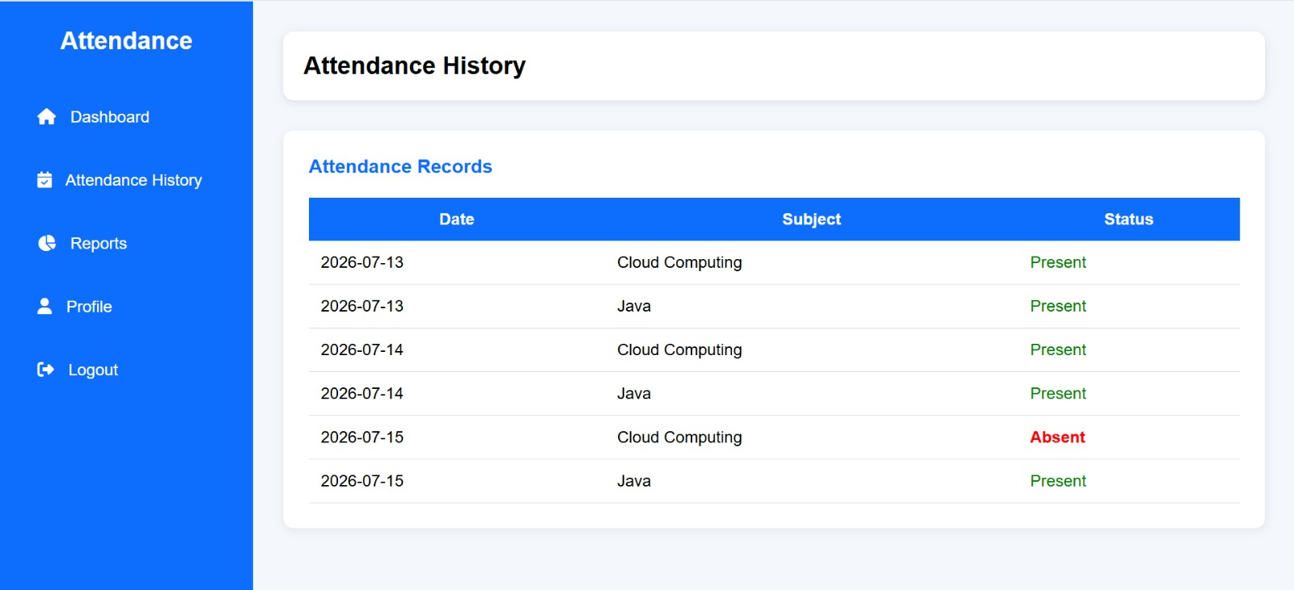

Student Dashboard-Report Page:-

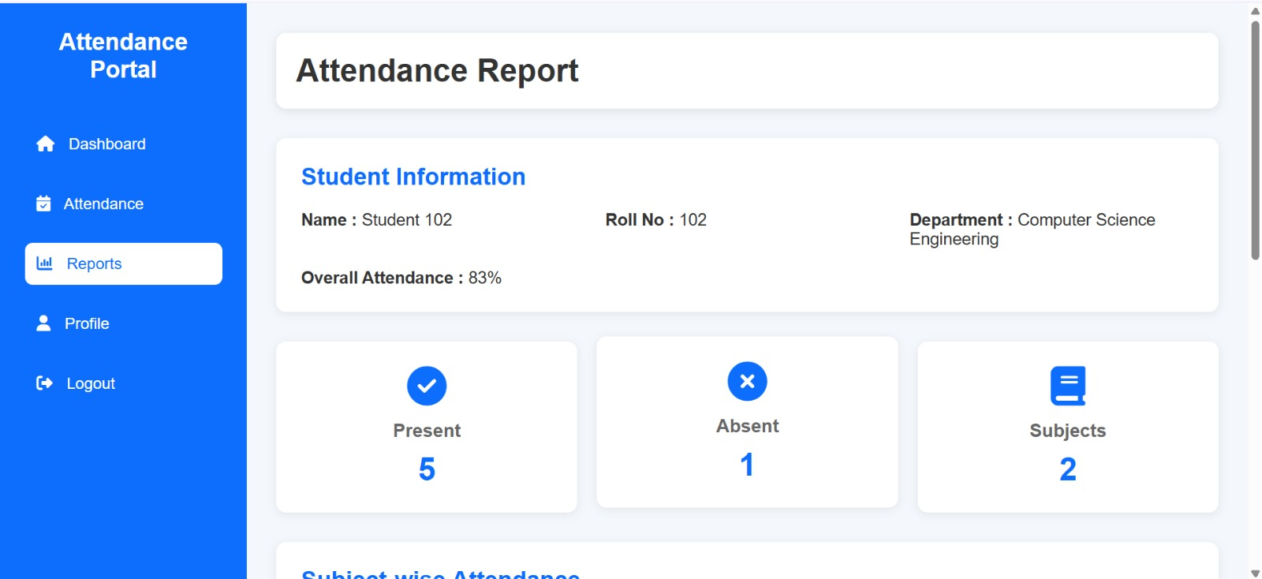
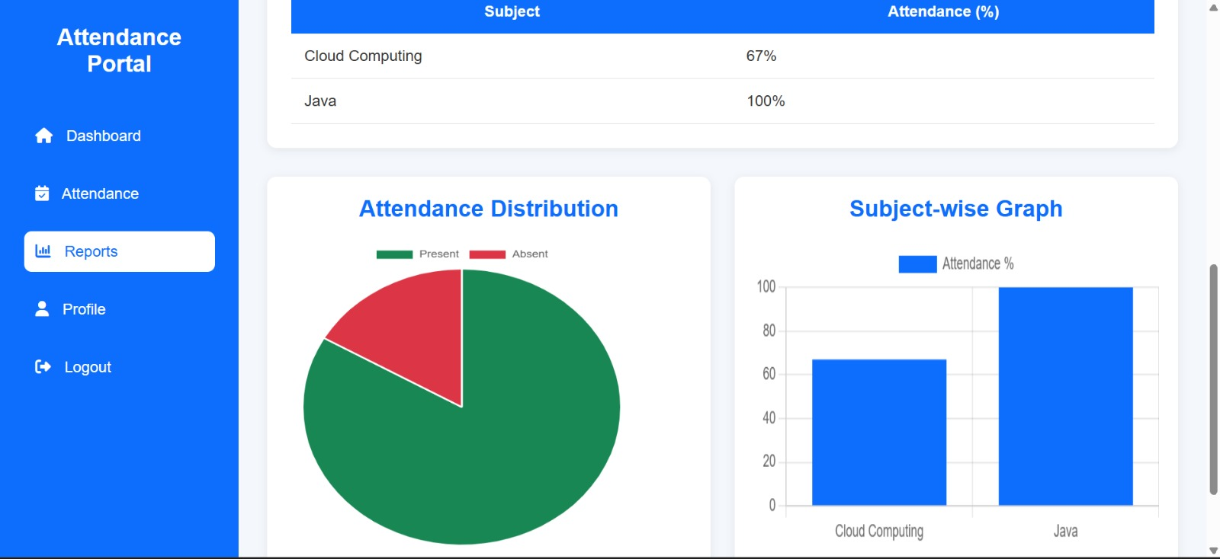

Student Dashboard-Profile Page:-
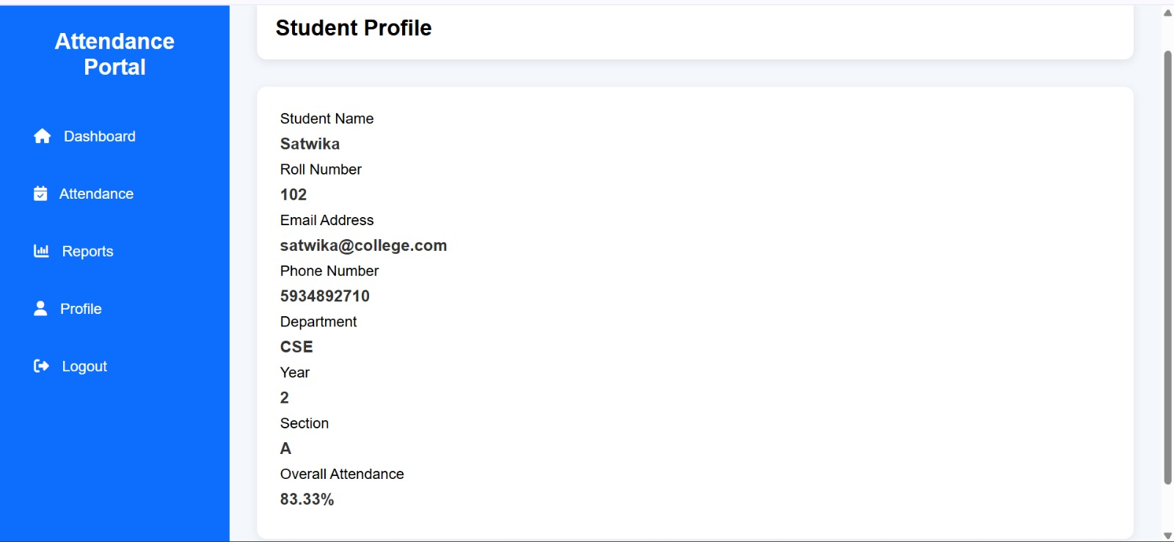

CHAPTER 7: CONCLUSION
7.1 Conclusion
The Serverless Student Attendance Management System was successfully designed, developed, and implemented using modern cloud computing and DevOps technologies. The main objective of this project was to create a secure, scalable, and efficient attendance management solution that reduces manual effort and improves the accuracy of attendance records.
The system utilizes AWS serverless services such as Amazon S3, Amazon API Gateway, AWS Lambda, Amazon DynamoDB, Amazon Cognito, IAM, and Amazon CloudWatch to provide a reliable cloud-based application without requiring traditional server management. The serverless architecture enables automatic scaling, high availability, and cost-effective resource utilization.
The implementation of AWS Lambda allowed backend operations to be executed efficiently, while Amazon DynamoDB provided fast and scalable storage for student and attendance data. Amazon Cognito ensured secure user authentication, and Amazon CloudWatch helped monitor application performance and troubleshoot issues..
The developed system successfully achieved its objectives by providing features such as secure login, attendance recording, attendance data management, and real-time access to attendance information. Testing results confirmed that the application functions effectively and provides a reliable solution for educational institutions.
In conclusion, this project demonstrates the practical application of serverless computing, cloud services, and DevOps practices in developing modern web applications. The proposed system provides a strong foundation for future enhancements such as mobile application support, QR-code-based attendance, biometric authentication, and AI-based attendance analytics.

